*Florida International University*

*School of Computing and Information Sciences*

CIS 4911 - Senior Capstone Project

Software Engineering Focus

Feature Document

User Story #498

**Team Member:**

Andrew Mitchell

**Product Owner(s)**:

Francisco R. Ortega

**Mentor(s)**:

Francisco R. Ortega

...

**Instructor**: Masoud Sadjadi

# 

# **User Story – Change Line Color**

* As a User I would like to change the color of the line I am drawing to make my drawings more diverse.

## **Use Case – Change Line Color**

Use Case

Change Line Color

Details:

Actor: User

Pre-conditions:

Touch screen working.

Able to draw lines.

Program Running.

Description:

Use case begins when a user presses a key (q or w, Temporary until design philosophy is completed). This will alter the color of the next line drawn. The User can continue to cycle forward with ‘w’ and backwards with ‘q’.

The user story ends when the user successfully draws a line with a new color.

Post-conditions:

Line changes color.

Can cycle through various colors.

Decision Support:

Frequency: Often. Many color changes will occur throughout a paintings lifetime.

Criticality: High. Enables more ways to paint on the canvas.

Risk: High. Team member needs to learn to use Magnum, C++, (LibCinder added as well) and know how to interact with a touch screen and deal with various inputs.

Constraints:

Usability:

Just need to learn the proper keybinding.

Reliability: Very Reliable.

Mean time to Failure – Should only fail in extreme conditions. (Keyboard input overloads etc).

Availability – Always available (may change at a future date).

Performance:

Color changes should be swift.

Should be able to cycle through (end on color 0, go to color FINAL, return to color 0 with one forward motion).

Supportability:

Must work with ACER Multitouch.

Modification History:

Owner: Andrew Mitchell

Initiation date: 01/30/2016

Date last modified: 02/01/2016

## 

## **Use Case Diagram**

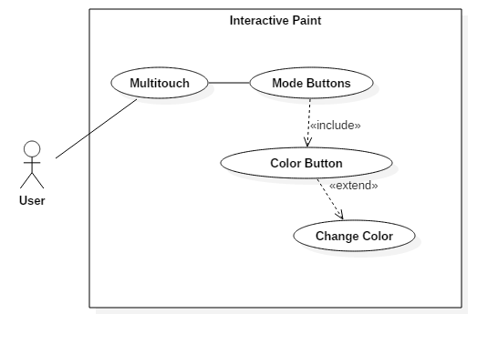

## **Sequence Diagram**

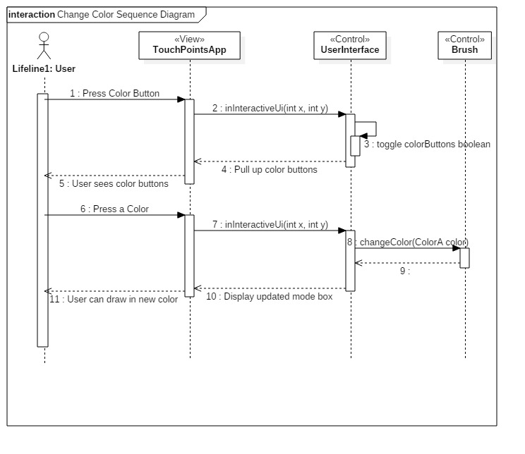

## 

## 

## **Class Diagram**

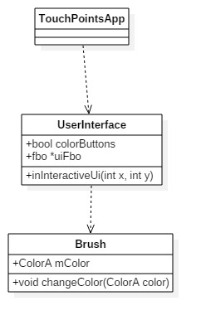

## 

## **Unit Test**

Sunny Day Tests

Test Case: Change Colors

Test Purpose: Ensure that we can change colors with the multitouch color change buttons.

Test Setup:

1. Press the Color wheel button at the top left corner.
2. Press the first color
3. Draw a Line
4. Repeat step 1 through 3 until you try every color

Test Output:

Every line drawn correctly corresponded to the proper color

Expected Output:

After pressing a multitouch color button the following shapes drawn should be in that corresponding color.

Rainy Day Tests

Test Case: Shapes in Different Colors

Test Purpose:

Ensure that the different colors work with different shapes

Test Setup:

1. Press the color wheel button at the top left corner
2. Press the 3rd color
3. Draw a line.
4. Press the shapes button and change to circle
5. Draw a circle

Test Output:

Both the line and circle were yellow.

Expected Output:

The line and circle should be the same color.

## 

## **Integration Test**

Color change can currently be done with a leap motion device, Real Sense Device, or multitouch.

It currently works with all shapes in TouchShapes as well.

The drawing works with leap motion, multitouch, and Real sense device.

## 

## **User Guide**

To change colors using the multitouch menu you can use the color button located at the top left of the screen with the multitouch enabled. If the eyeX is enabled you will have to gaze towards the top left corner to open up the menu.

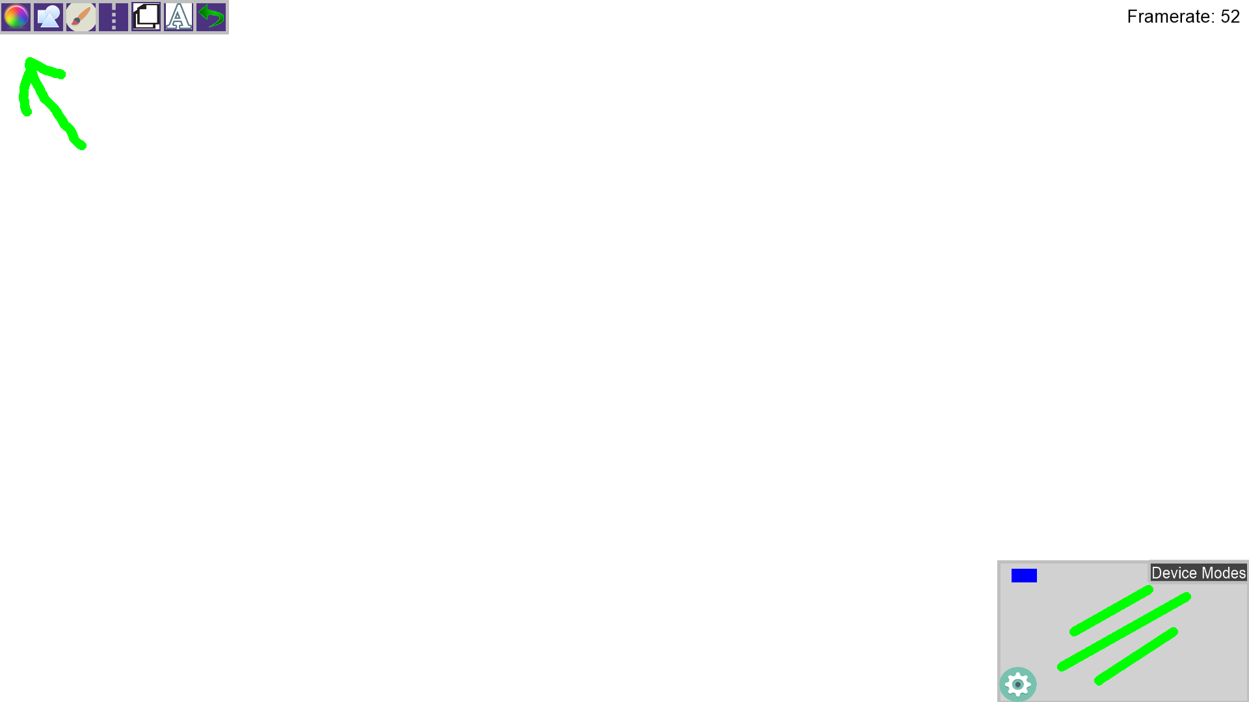

Once you tap the button you can view all the various colors available to you. Select any color to change the color of your shapes!

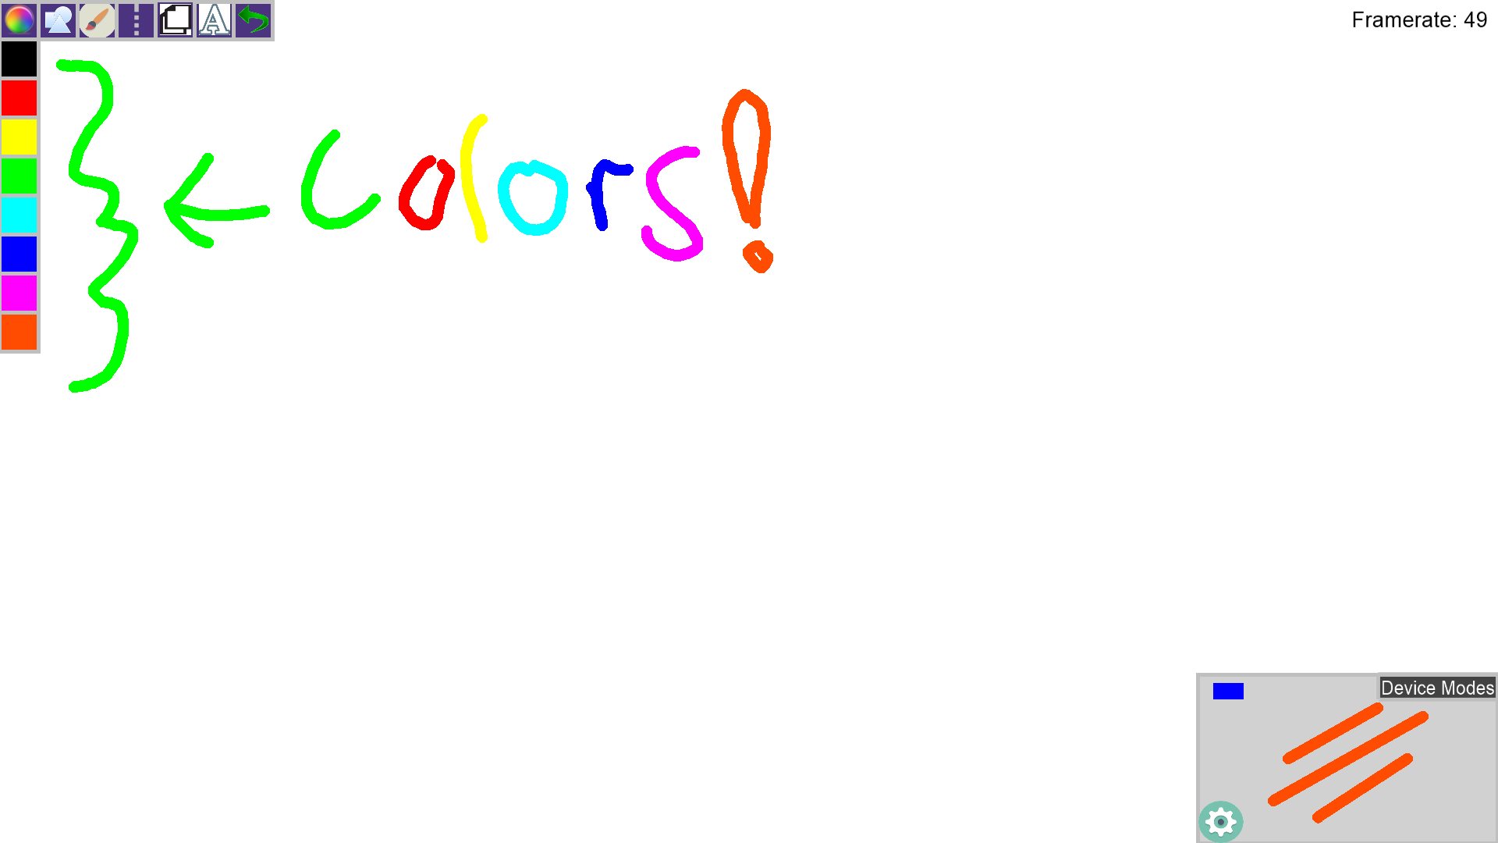

**Glossary**

Line Color – The color of any shapes you draw with the leap motion, real sense, or multitouch devices.